SESSION 1(18/05/2025):
Project Time line
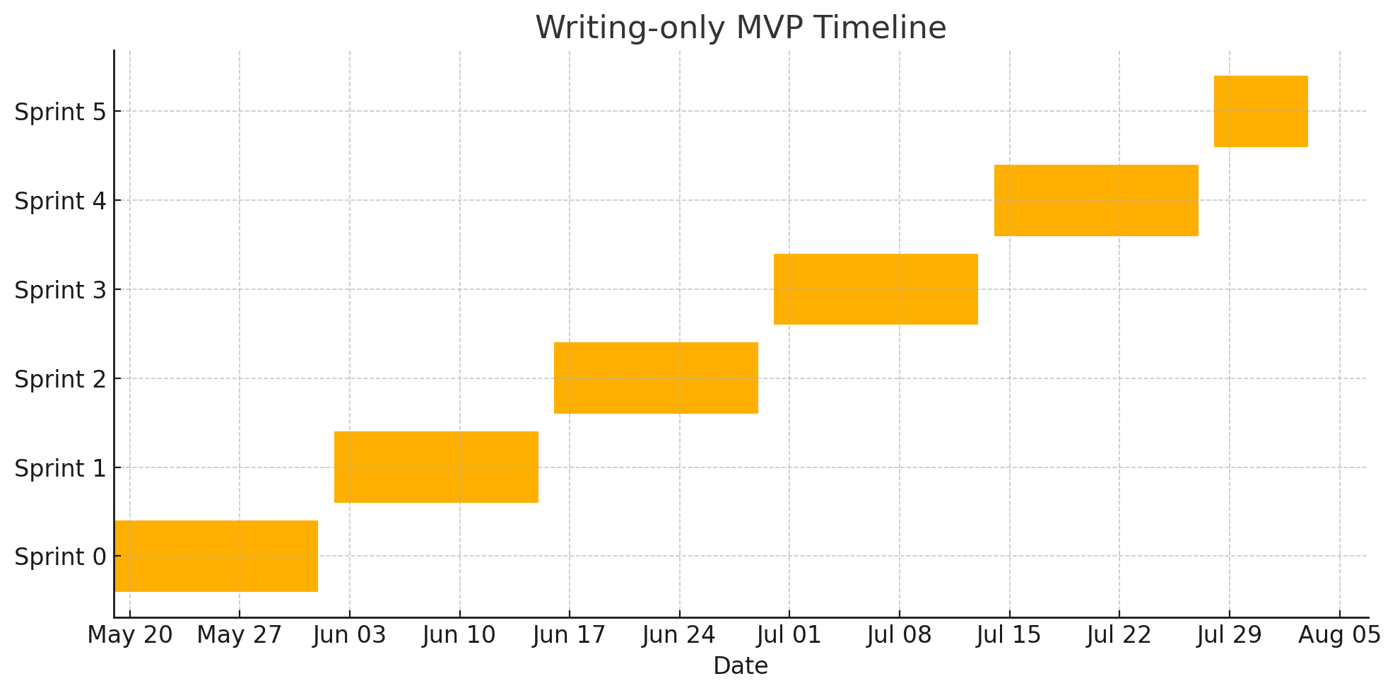
Here’s a concise recap of our planning session:

Project Scope & Requirements
- Initial focus: IELTS Writing (Task 2 only, 250-word essays)
- Future expansion: Task 1, then Reading, Listening, Speaking
- Scoring:
  - Official IELTS band descriptors (Task Response; Coherence & Cohesion; Lexical Resource; Grammatical Range & Accuracy)
  - Deterministic grading via OpenAI (gpt-4-turbo, temperature=0, structured JSON)
- Feedback:
  - Inline, color-coded highlights with hover-triggered comments
  - Full-page teacher-style annotations embedded in the essay
  - Model answer for comparison
- User accounts:
  - Signup/login (NextAuth.js + Flask-Login), test history saved

Architecture & Tech Stack
- Frontend: Next.js (React) + Tailwind CSS
- Backend: Flask + Flask-RESTful + SQLAlchemy + Marshmallow
- Database: PostgreSQL (JSON columns for raw API data)
- Core data models:
  - User, TestSession, TestSessionTask, Submission, Annotation

API Endpoints (Sketch)
- POST /api/auth/signup & /api/auth/login
- POST /api/test_sessions → generate Task 2 prompt
- GET /api/test_sessions/{id}/tasks → fetch prompts & model answers
- POST /api/submissions → submit essay, trigger grading & annotation
- GET /api/submissions/{id} → retrieve scores, feedback, model answer

Timeline (Writing-only MVP)
Sprint | Dates | Goals
Sprint 0 | May 19 – Jun 1, 2025 | Setup Git/GitHub; Next.js & Flask “hello world”; PostgreSQL install
Sprint 1 | Jun 2 – Jun 15, 2025 | Define SQLAlchemy models; implement signup/login flows
Sprint 2 | Jun 16 – Jun 29, 2025 | “Generate Task 2” UI; store prompts; build submission form
Sprint 3 | Jun 30 – Jul 13, 2025 | Integrate OpenAI grading (JSON schema, temperature=0); persist scores & feedback
Sprint 4 | Jul 14 – Jul 27, 2025 | Render inline annotations with hover/tooltips; display model answers
Sprint 5 | Jul 28 – Aug 3, 2025 | End-to-end testing, UX polish, basic automated tests

Cost Estimate (≈ 50 submissions/week)
- All gpt-4-turbo: ~$0.09/submission → ~$18 /month
- Mixed (gpt-3.5 for prompts + gpt-4 for grading): ~$0.0326/submission → ~$6.50 /month
- Optimizations: cache prompt variants & model answers

With this foundation, you have a clear roadmap—from MVP feature set through architecture, timeline, and budget—to build and iterate your IELTS Writing platform. Let me know if you’d like to dive deeper into any part or adjust the plan!

